Application Pack

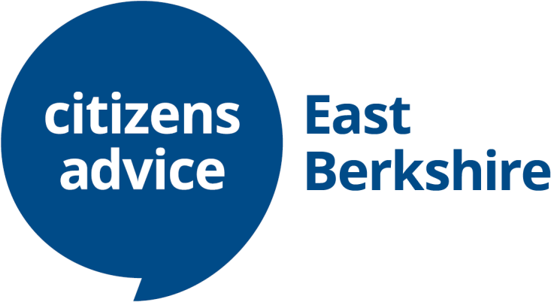

Welcome from our Chief Executive
Thank you for your interest in working and/ or volunteering for Citizens Advice East Berkshire.

At Citizens Advice, we have been solving life’s problems for over 80 years. We are often the only place left locally that people can seek free, independent, confidential, and impartial advice on social welfare. We are there to help them get their lives back on track.

2021 was a year of renewal following COVID and our merger of two charities for the benefit of the whole of East Berkshire. We will stay local, whilst benefitting from shared management and infrastructure that allows us to invest in additional support and training for our dedicated volunteers who are the backbone of our service.

Our staff and volunteers are passionate about what they do because they know they can make a real difference to peoples’ lives. We would love you to join our team to help deliver our vision of a sustainable and growing charity reaching out into our communities, being able to be there for everyone when they need us most.

We encourage you to apply and look forward to talking to you!

Application process

All applications must be made using the application form provided. CVs will not be accepted. The closing date for applications is 24th April 2022 at 11:30pm.
Applications should be sent to recruitment@caeb.org.uk

Interviews will be held in late April/ early May 2022.

Contents
In this pack you’ll find:

- Background information
- Our values
- 3 things you should know about us
- About Citizens Advice and the merger

Background
Citizens Advice East Berkshire is a newly merged organisation who are seeking amazing people to join us and help shape our services to meet our clients’ future needs. If your circumstances require more flexibility, we are pleased to consider this.

Citizens Advice services are provided locally by unique local charities, backed by a national network. Citizens Advice Bracknell and District and Citizens Advice Maidenhead and Windsor have decided to merge because together we are stronger and more resilient allowing us to grow our vital services.

We offer free, independent, confidential and impartial advice for everyone, empowering and solving their problems together. We are there for anyone who needs us in our local communities. We are there to help them get their lives back on track.
Our values
We’re inventive. We’re not afraid of trying new things and learn by getting things wrong. We question every idea to make it better and we change when things aren’t working.
We’re generous. We work together, sharing knowledge and experience to solve problems. We tell it like it is and respect everyone.
We’re responsible. We do what we say we’ll do and keep our promises. We
remember that we work for a charity and use our resources effectively.
3 things you should know about Citizens Advice
- We’re local and we’re national. We have 6 national offices and offer direct support to people in around 300 independent local Citizens Advice services across England and Wales.

- We’re here for everyone. Our advice helps people solve problems and our advocacy helps fix problems in society. Whatever the problem, we won’t turn people away.
- We’re listened to - and we make a difference. Our trusted brand and the quality of our research mean we make a real impact on behalf of the people who rely on us.

The merger at a glance

Turnover:
>£0.5m
c.30 staff
c.120
volunteers

Our timeline
April 2020

- The two boards of trustees begin discussing collaboration, & decide in June to prepare merger business case in June
October 2020

- Agreement to merge finalised and announced
April 2021

- Merger is complete – Citizens Advice East Berkshire formally created. New strategy and full integration begins.

Our merging charities

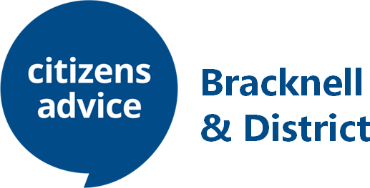

12 staff
60 volunteers Income: £203,000
18 staff
61 volunteers Income: £340,329

Overview of Citizens Advice

The Citizens Advice service is made up of Citizens Advice - the national charity - and a network of around 300 independent local Citizens Advice charities. They deliver services from:  - over 600 local Citizens Advice outlets.  - over 1,800 community centres, GP surgeries and prisons.  They do this with:  - 6,500 local staff  - over 23,000 trained volunteers  Our reach means 99% of people in England and Wales can access a local Citizens Advice within a 30-minute drive of where they live. | 